**ID APPLICATION FOR FRESHMEN**

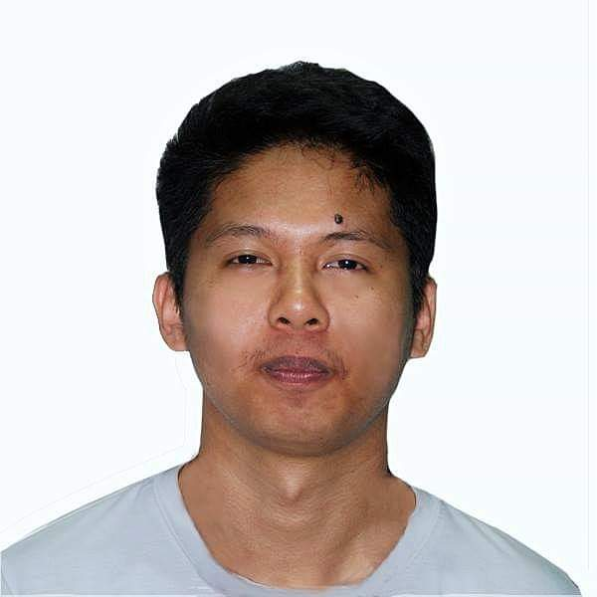STUDENT NUMBER: 2X2 PHOTO SIGNATURE

2019-00544-SR-0

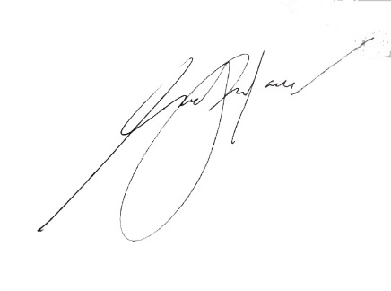LAST NAME:

PORLARES

FIRST NAME: MIDDLE NAME: COURSE: BIRTHDAY:

SANCHEZ

AARON

BSIT

2001-04-28

ADDRESS || CONTACT PERSON || CONTACT NUMBER

BLK 189 LT 11 PH2 MABUHAY CITY MAMATID, CABUYAO CITY, LAGUNA||JOSEFINA S. PORLARES||09157429509

complete your application by uploading a clear scanned copy of this form at <http://bit.ly/pupsrc101idapplication>